Process Document of NVH Work Request
Submitted to:
Kirloskar Oil Engine Limited(KOEL)
Date: 23 September 2020

Document History:

Version | Author | Date | Comments
1.0 | Rohan Indalkar | 19/09/2020

Table of Contents
1. New Work Request Document Creation Steps: 4
2. Work Request Process: 7
3. NVH Test Report Creation & Approval: 11
4. Work Request Dashboard: 14

New Work Request Document Creation Steps:
- Go to browse tab then go to Libraries the go to Work Request library and then in the Folders.
Click Browse Tab Libraries Work Request Folders

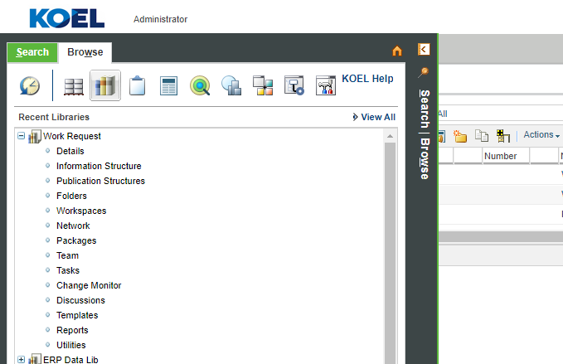

- In folders go to Work Request Testing folder.
Folders Work Request NVH
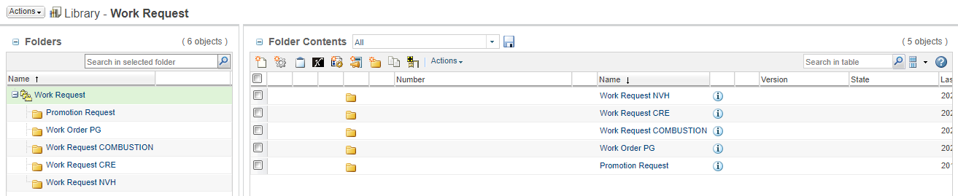

- Now click on New Document to create new Work Request document.

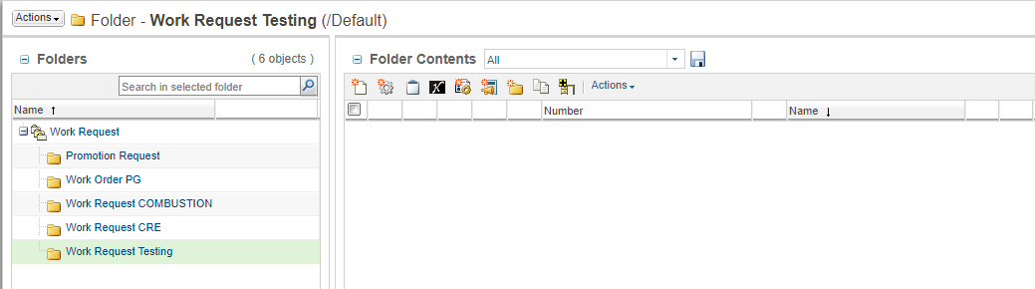

- Then click on the select type and select type as NVH Work Request.
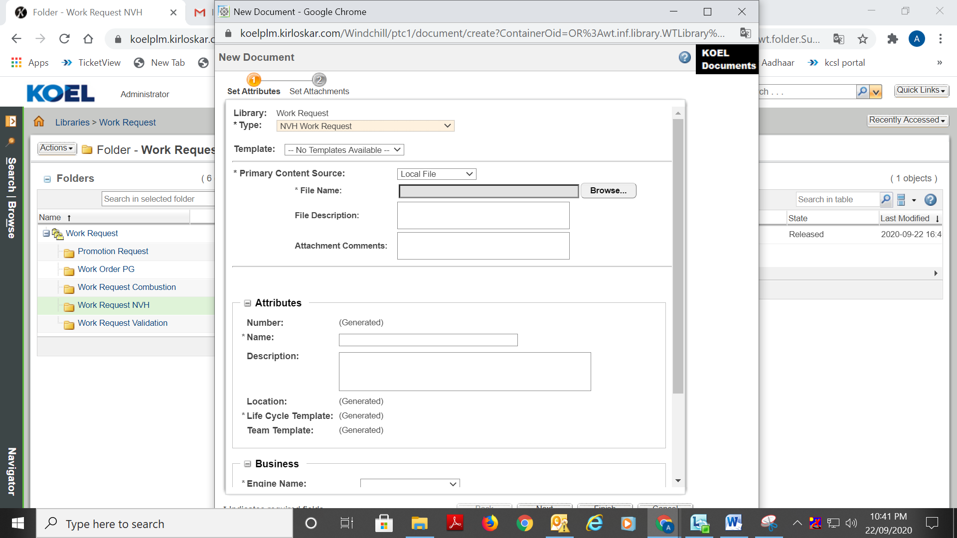

- Attach source file to Work Request through browse button
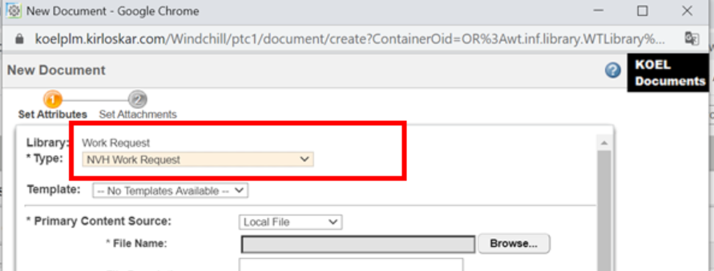
- Fill the mandatory details and click on Next button.
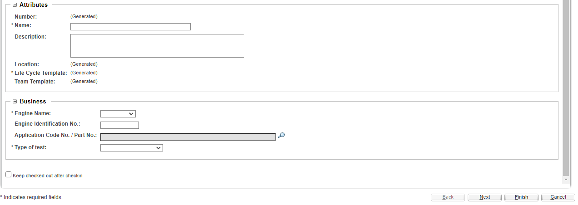

- Click on search icon to select part no. (If required) below window appears. Enter valid details to search part no. & select Design view of the required part.
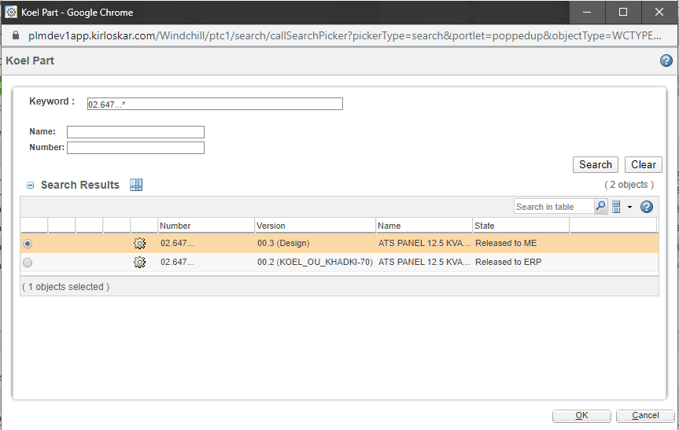

- Attach if there are any extra attachments then click on the finish button.

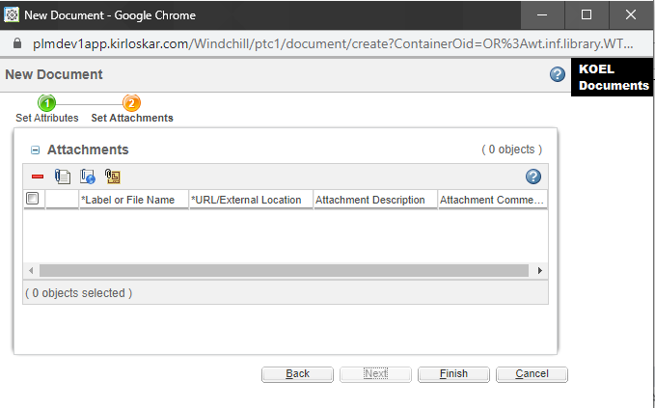

Work Request Process:
- Once document is created successfully it appears as follows.
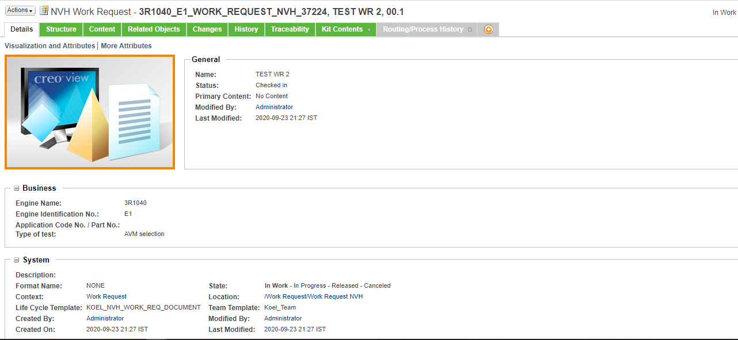

- If part no is given while work request creation:
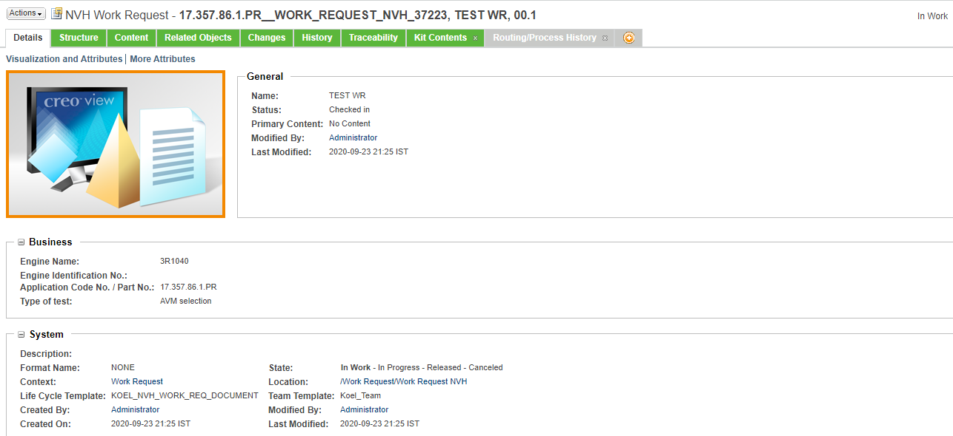

- Select Routing/Process History tab for viewing / completion of tasks.
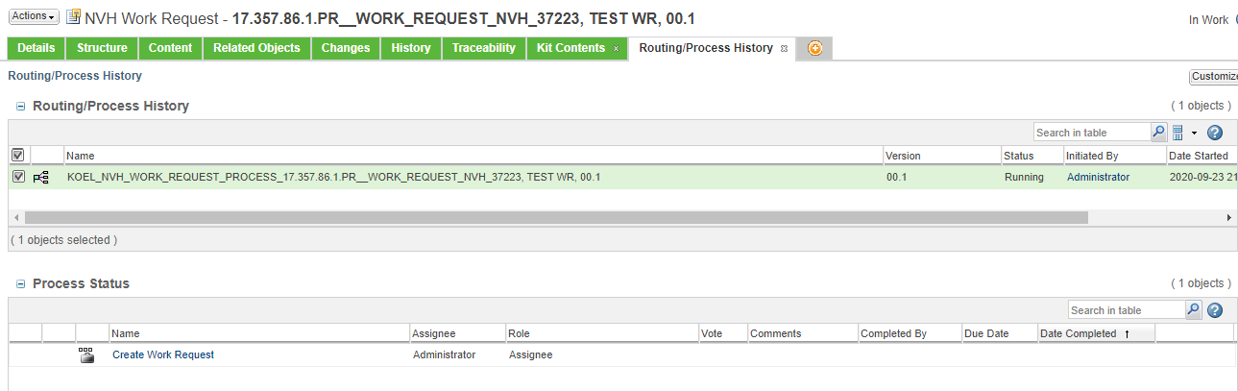

- First task is to Create Work Request which is assigned to document creator. As per the given instructions on task page user completes the task.
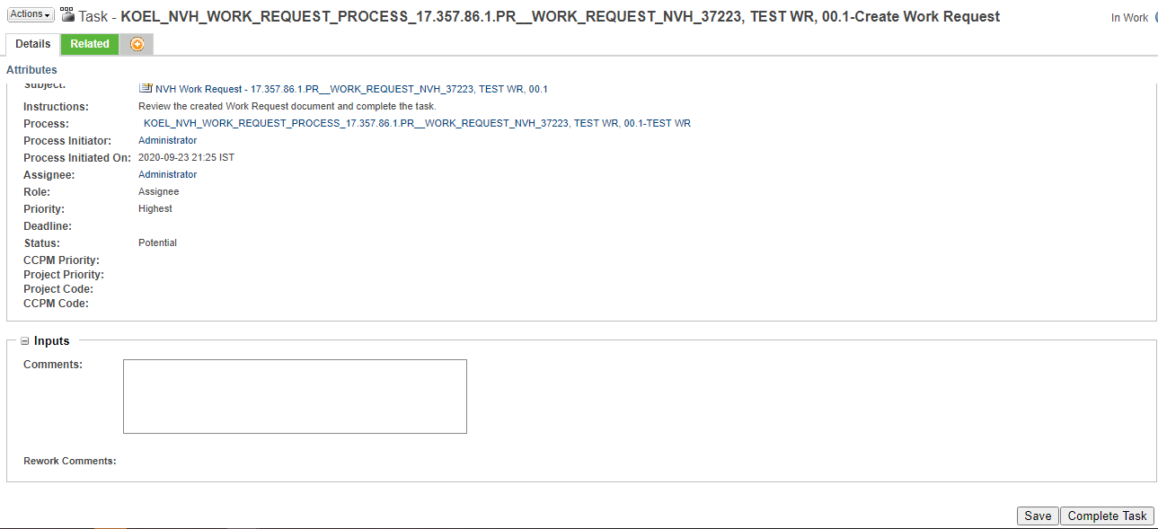

- Next task Review Work Request is assigned to Technical Co-ordinator.

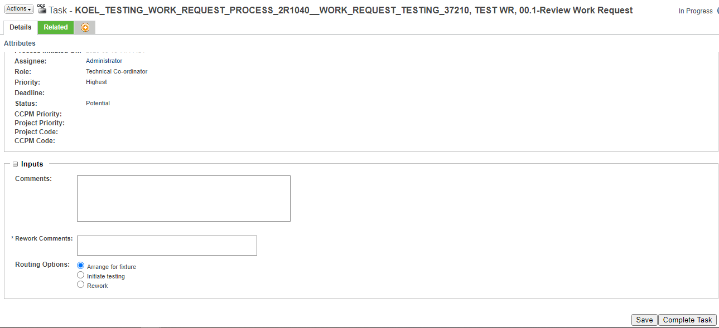

  - If Technical Co-ordinator selects Rework & completes the task Create Work Request task is again opened & assigned to work request creator.
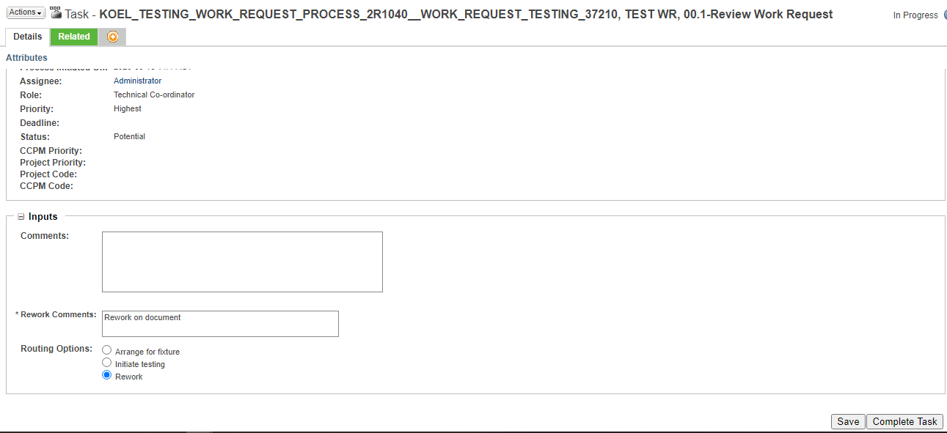
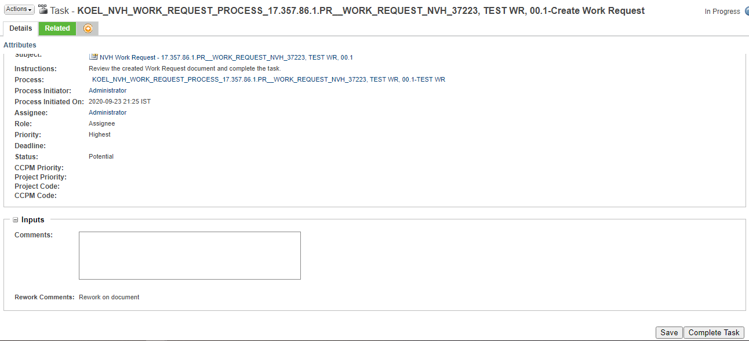

  - If Technical Co-ordinator selects Arrange for fixture & completes the task Arrange for fixture is assigned to NVH Test Engineer.
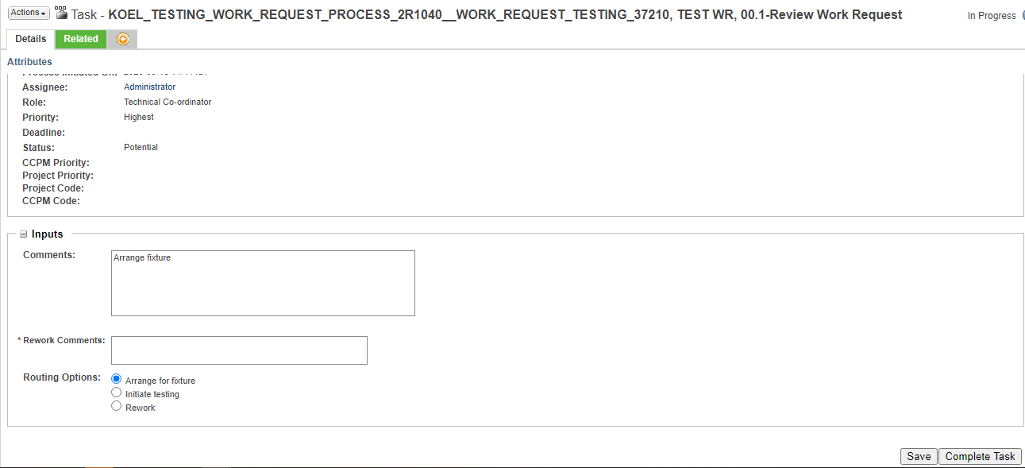

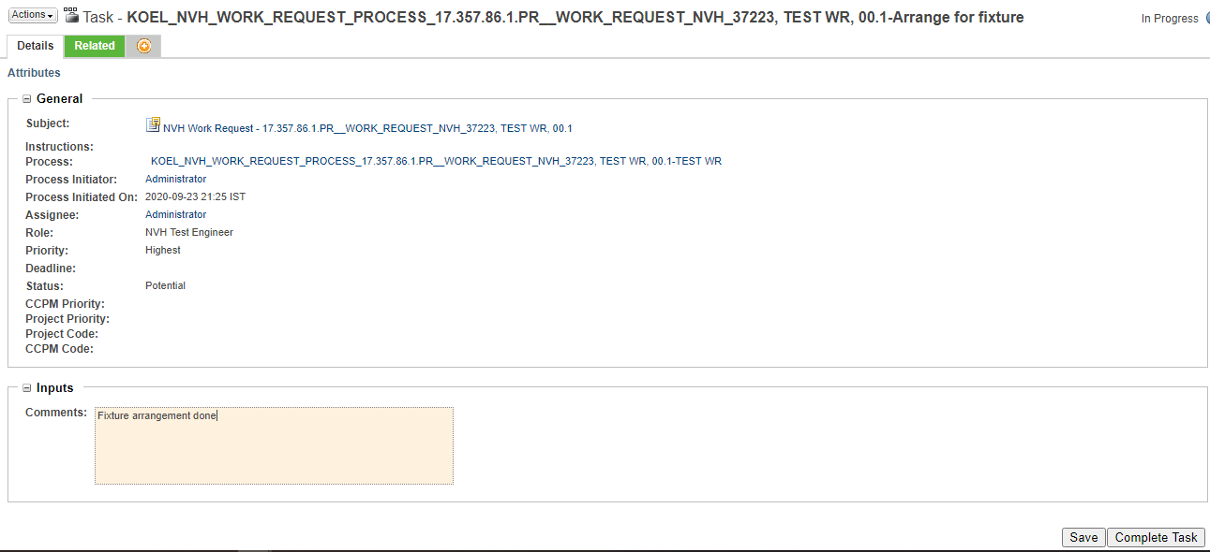

  - On completion of above task next task Attach NVH Testing Report is assigned to NVH Test Engineer. User has to select link in task & create testing report.
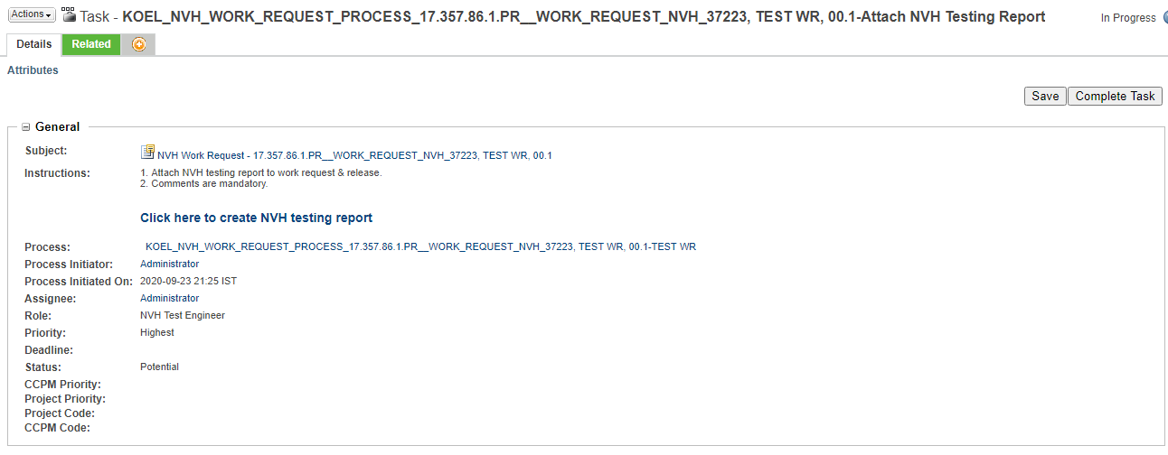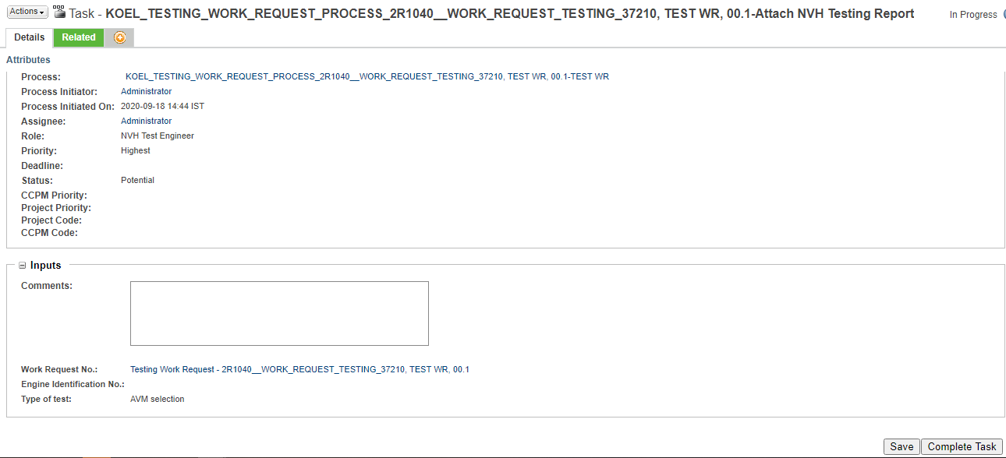

  - After creation of NVH Testing report it has to be individually approved through another approval process set on the document & after approval it gets automatically attached to Work request.
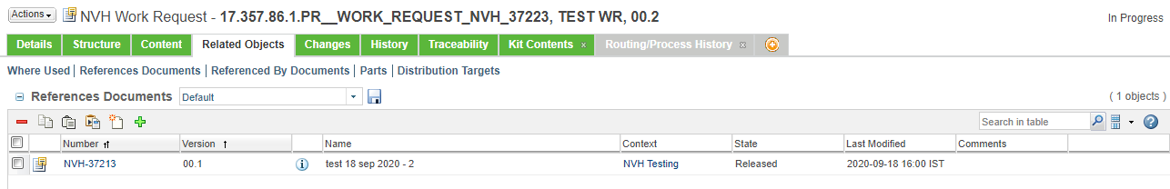

- On completion of above task next task Close Work Request is assigned to Technical Co-ordinator.
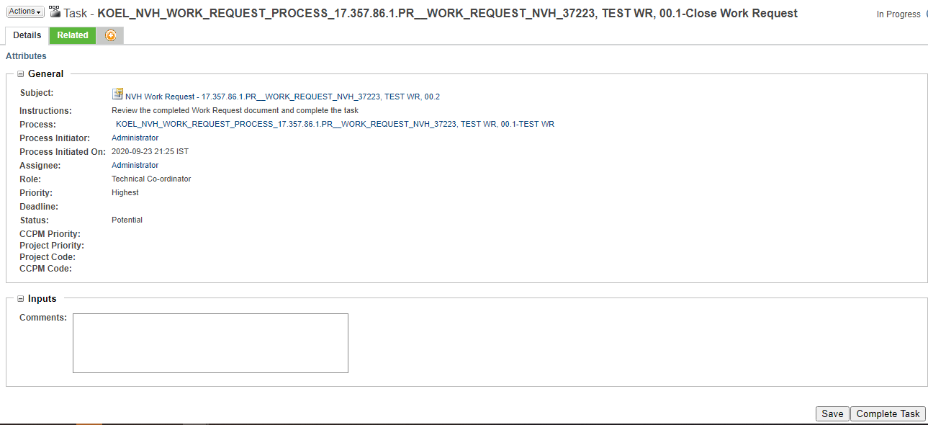

  - On completion of task Work Request state changes to Released & it gets attached to related App code / Part no.
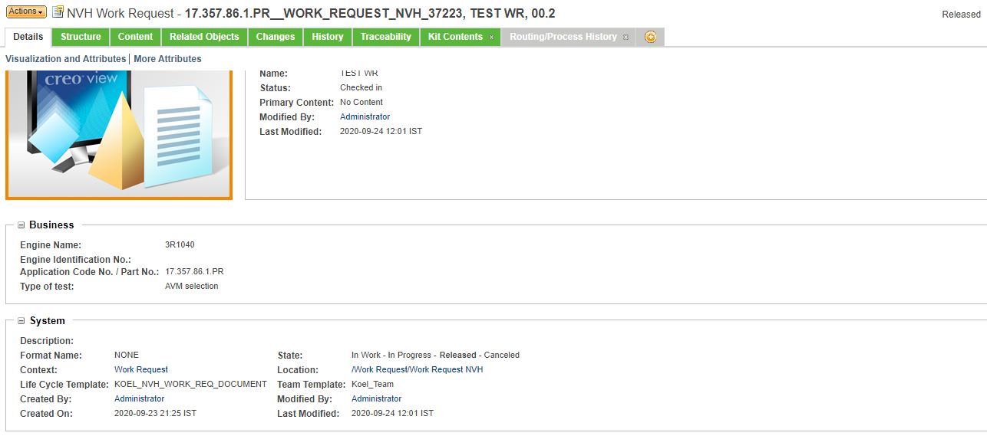

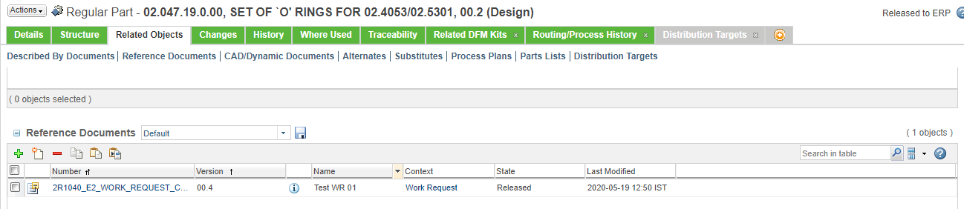

Note:
- If Part no. is not given process is completed directly.
- Notifications are set as per the progress of work request.

NVH Test Report Creation & Approval:

- Report can be created by going to browse tab then go to Libraries the go to NVH Testing library and then in the Folders or through the link given on task page.
Click Browse Tab Libraries NVH Testing Folders

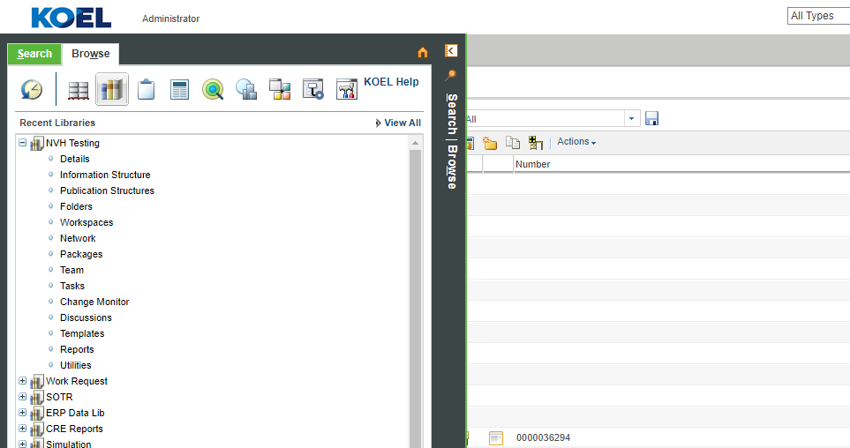

- Go to Create new document.

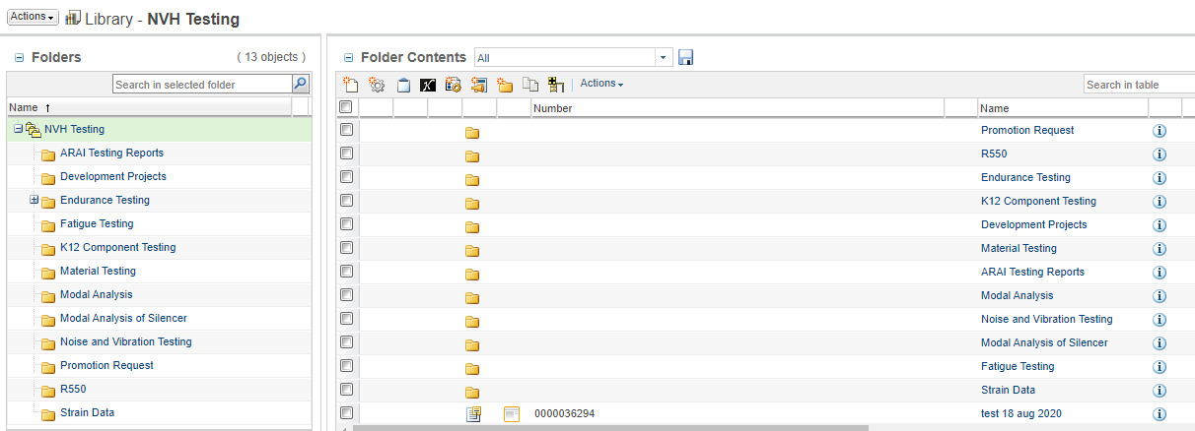

- Select type Swirl Lab Testing Reports from select type.

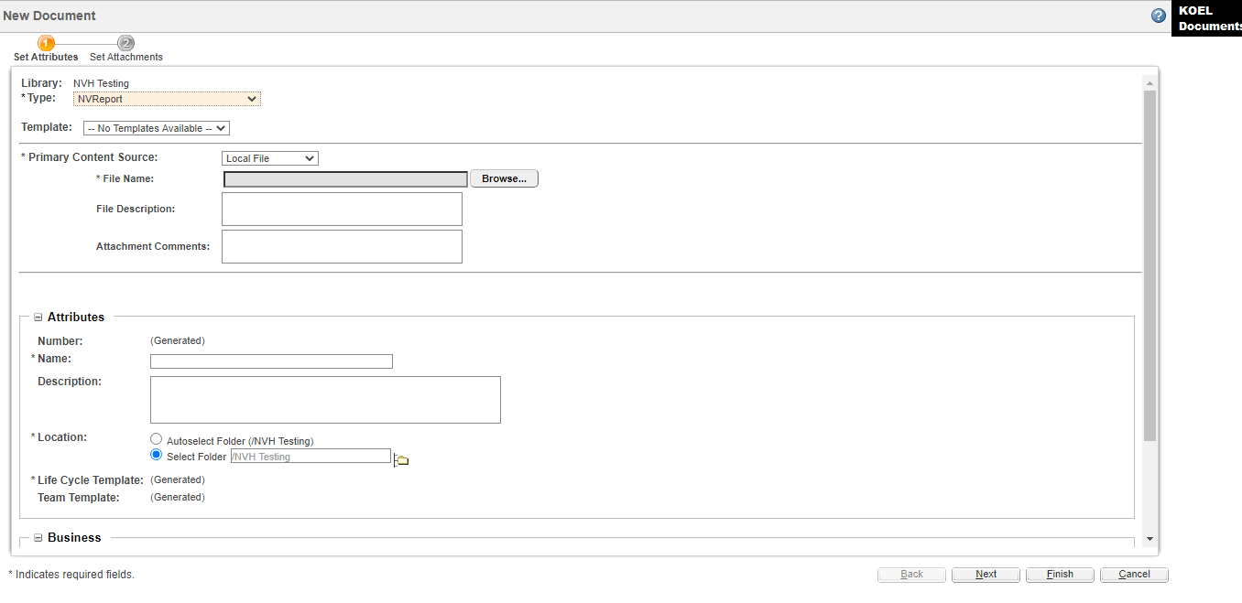

- Attach source file to NVH testing report through browse button.


- Fill all the mandatory fields and click on finish.

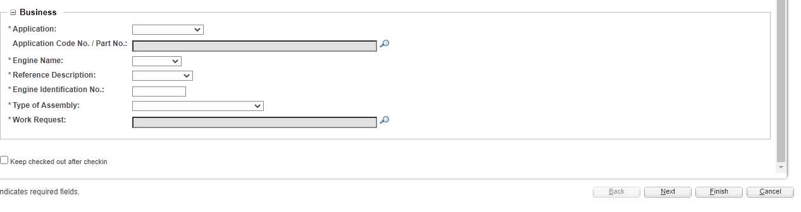

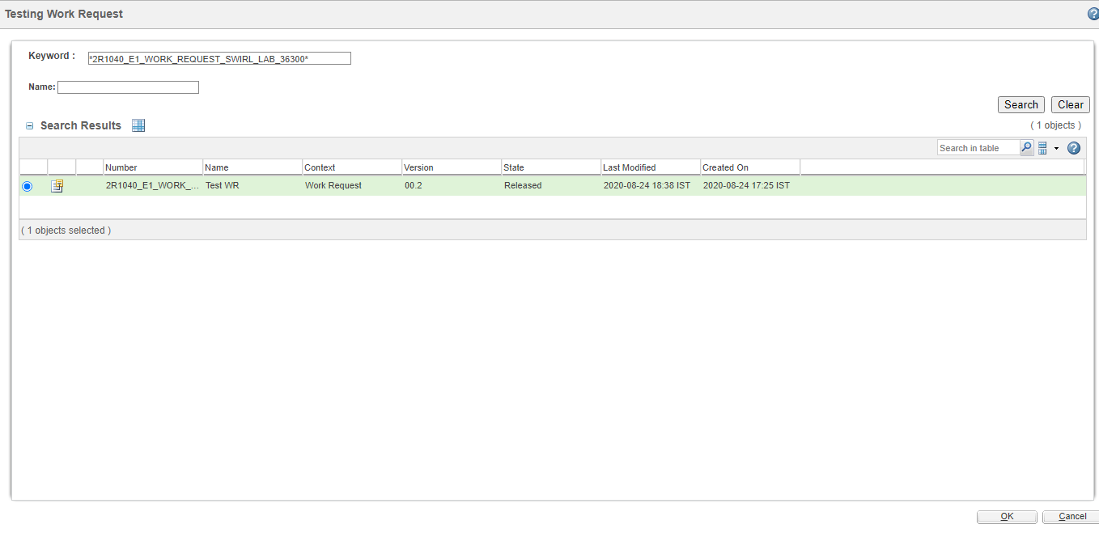

- On creation of the document approval task is assigned to NVH Report Reviewer depending on the group in which document creator belongs to Combustion HHP group or Combustion LHP & MHP group. Approver can Approve / Rework document for changes.
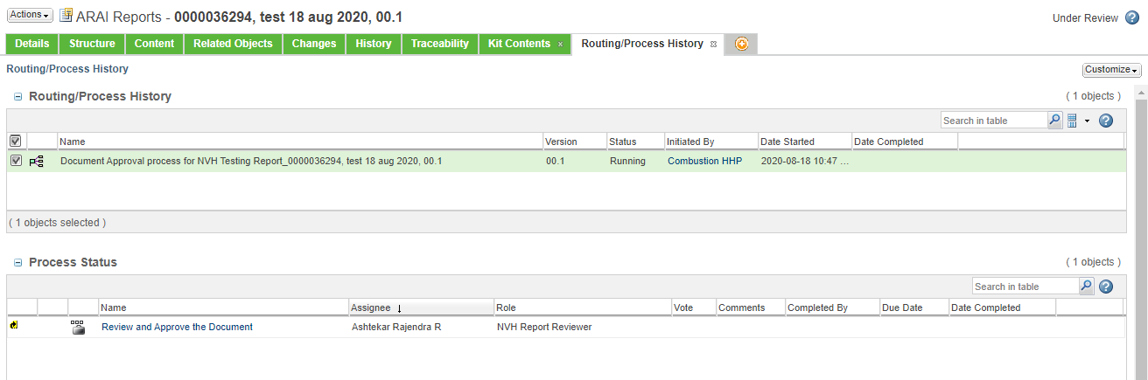
- On approval document state changes & it gets attached to respective Work Request.
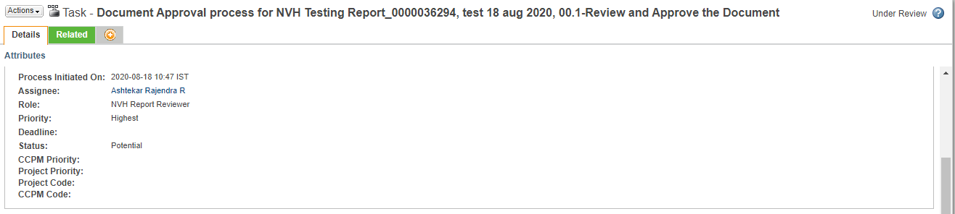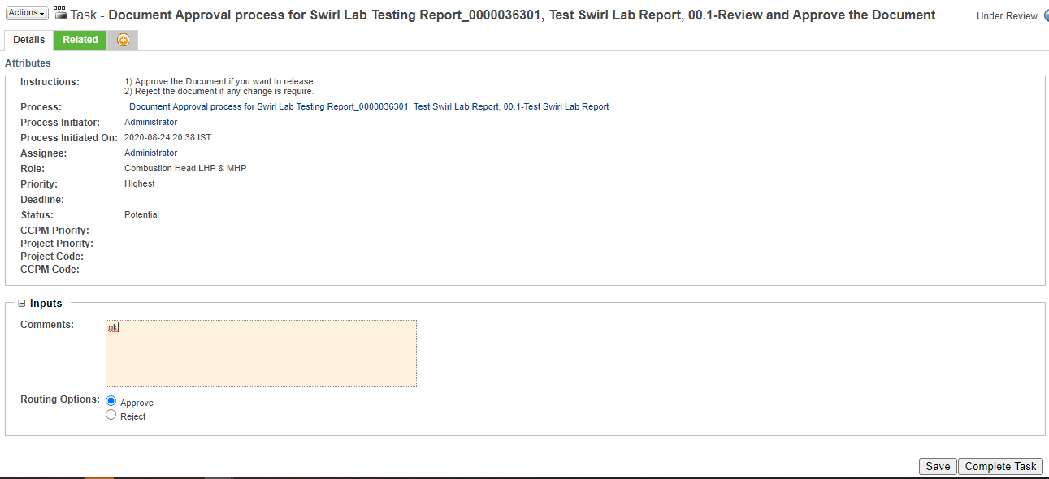

Work Request Dashboard:

